# NARROGIN Senior High School

### Year 11 Examination, 2015

### Question/Answer Booklet

If required by your examination administrator, please place your student identification label in this box

# MATHEMATICS

# APPLICATIONS

# UNITS 1 AND 2

## Section Two:

## Calculator-assumed

|  |  |  |  |  |  |  |  |  |
| --- | --- | --- | --- | --- | --- | --- | --- | --- |
| Student Number: In figures |  |  |  |  |  |  |  |  |

In words

Your name

## Time allowed for this section

Reading time before commencing work: ten minutes

Working time for this section: one hundred minutes

## Materials required/recommended for this section

##### *To be provided by the supervisor*

This Question/Answer Booklet

Formula Sheet (retained from Section One)

##### *To be provided by the candidate*

Standard items: pens (blue/black preferred), pencils (including coloured), sharpener,

correction fluid/tape, eraser, ruler, highlighters

Special items: drawing instruments, templates, notes on two unfolded sheets of A4 paper, and up to three calculators approved for use in the WACE examinations

## Important note to candidates

No other items may be taken into the examination room. It is **your** responsibility to ensure that you do not have any unauthorised notes or other items of a non-personal nature in the examination room. If you have any unauthorised material with you, hand it to the supervisor **before** reading any further.

## Structure of this paper

|  |  |  |  |  |  |
| --- | --- | --- | --- | --- | --- |
| Section | Number of questions available | Number of questions to be answered | Working time (minutes) | Marks available | Percentage of exam |
| Section One:  Calculator-free | 8 | 8 | 50 | 52 | 35 |
| Section Two:  Calculator-assumed | 12 | 12 | 100 | 98 | 65 |
|  | | | **Total** | 150 | 100 |

## Instructions to candidates

1. The rules for the conduct of examinations are detailed in the school handbook. Sitting this examination implies that you agree to abide by these rules.
2. Write your answers in this Question/Answer Booklet.
3. You must be careful to confine your response to the specific question asked and to follow any instructions that are specified to a particular question.
4. Spare pages are included at the end of this booklet. They can be used for planning your responses and/or as additional space if required to continue an answer.

* Planning: If you use the spare pages for planning, indicate this clearly at the top of the page.
* Continuing an answer: If you need to use the space to continue an answer, indicate in the original answer space where the answer is continued, i.e. give the page number. Fill in the number of the question that you are continuing to answer at the top of the page.

1. **Show all your working clearly**. Your working should be in sufficient detail to allow your answers to be checked readily and for marks to be awarded for reasoning. Incorrect answers given without supporting reasoning cannot be allocated any marks. For any question or part question worth more than two marks, valid working or justification is required to receive full marks. If you repeat any question, ensure that you cancel the answer you do not wish to have marked.
2. It is recommended that you **do not use pencil**, except in diagrams.
3. The Formula Sheet is **not** to be handed in with your Question/Answer Booklet.

Section Two: Calculator-assumed (98 Marks)

This section has**twelve (****12)** questions. Answer **all** questions. Write your answers in the spaces provided.

Working time for this section is 100 minutes.

Question 9 (6 marks)

A triangle has sides of lengths 7 cm, 11 cm and 12 cm.

(a) Use Heron's rule to determine the area of the triangle. Show your working. (3 marks)

(b) Use trigonometry to determine the size of angle between the 11 cm and 12 cm sides, rounding your answer to the nearest degree. Show your working. (3 marks)

Question 10 (10 marks)

A stall at a market sells pancakes for $2.50 each. The total cost of making the pancakes and hiring a stall are given by , where C is the cost in dollars and x is the number of pancakes sold.

(a) If the stall sells 40 pancakes, determine

(i) the cost of making the pancakes. (1 mark)

(ii) the total amount the pancakes were sold for. (1 mark)

(iii) the profit made by selling the pancakes. (1 mark)

(b) Graph the rule  on the axes below. (2 marks)

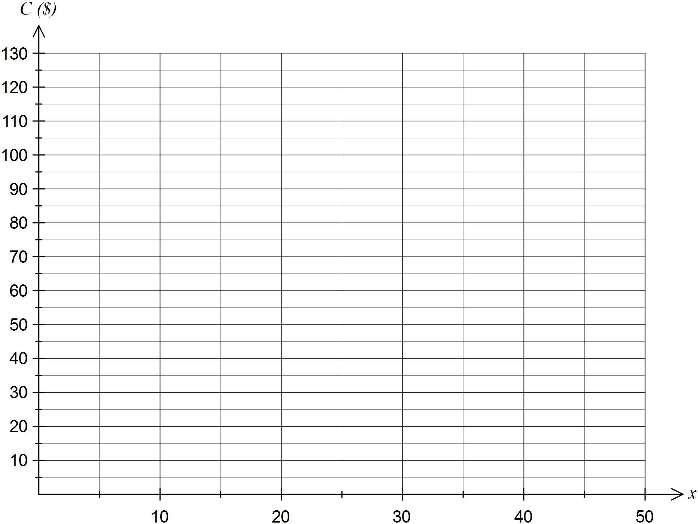

(c) The revenue, R dollars, from selling x pancakes is given by the formula .

State the value of m. (1 mark)

(d) Add the revenue rule to the graph. (2 marks)

(e) Determine how many pancakes must be sold for the stall to break even. Explain how you found your answer. (2 marks)

Question 11 (8 marks)

A young person qualifies for youth allowance of $426.80 per fortnight, so long as she does not earn more than $427 before tax in that time.

In any fortnight that she does earns more than $427, her allowance will be reduced by 50 cents in the dollar for earnings over $427 and up to $512, and reduced by 60 cents in the dollar for earnings over $512.

(a) Assuming that there are exactly 52 week in a year, determine the monthly amount of youth allowance paid, if the young person has no weekly earnings. (2 marks)

(b) The young person is considering a part time job for 14 hours per week that pays $17.75 per hour.

(i) Calculate her fortnightly earnings. (1 mark)

(ii) Determine the amount her youth allowance payment will be reduced by. (2 marks)

(iii) Determine her total fortnightly income from her job and allowance. (2 marks)

(c) The government plan to increase the fortnightly youth allowance rate by 2.8%. Determine the new rate. (1 mark)

Question 12 (6 marks)

(a) A rectangular picture frame measures 22 cm by 42 cm. Determine the length of the diagonal of the frame, rounding your answer to one decimal place. (2 marks)

(b) A square sheet of wood has a diagonal of length 170 cm. Determine the dimensions of the sheet of wood. (2 marks)

(c) A rectangular box has dimensions 25 cm by 30 cm by 50 cm. Can a thin, straight rod of length 60 cm could be placed inside the box? Justify your answer. (2 marks)

Question 13 (9 marks)

The number of phone calls per hour to a call centre over a 24-hour period are listed below.

23, 12, 32, 33, 54, 49, 18, 23, 16, 19, 38, 14, 42, 32, 19, 50, 27, 34, 14, 24, 25, 17, 45, 30

(a) Explain why the above data is classified as discrete. (1 mark)

(b) Complete the **ordered** stem-and-leaf plot below for this data. (3 marks)

Key: 1|2 = 12 calls

|  |  |
| --- | --- |
| Stem | Leaf |
| 1 | 2 |
| 2 | 3 |
|  |  |
|  |  |
|  |  |

(c) Determine the mean and median number of calls per hour and state which is more appropriate for describing the average number of calls per hour. (3 marks)

(d) The call centre is overloaded if more than 36 calls per hour occur. Determine the percentage of the above 24-hour period that the call centre was overloaded. (2 marks)

Question 14 (8 marks)

A shopper found the same item on three different websites, as shown in the table below. The total cost to the shopper is the price of the item plus shipping.

|  |  |  |  |
| --- | --- | --- | --- |
| Location of website | Australia | Great Britain | Hong Kong |
| Local currency | Australian dollar  AUD | Great Britain pound  GBP | Hong Kong dollar  HKD |
| Item cost in local currency | 149.95 | 79.95 | 995 |
| Shipping cost | 11.95 | 7.95 | 149 |

At the time, the exchange rates for one Australian dollar were 0.5655 GBP and 7.2254 HKD.

(a) Determine the total cost of the item from the Australian website. (1 mark)

(b) The shipping cost for the Australian website is close to 8% of the item cost. Determine for which website the shipping cost is the highest as a percentage of the item cost, and state what this percentage is. (2 marks)

(c) Determine the website that offers the lowest total cost for the item in Australian dollars. Justify your answer. (4 marks)

(d) The item cost in Australian dollars includes GST of 10%. Determine the amount of GST included in the item cost. (1 mark)

Question 15 (10 marks)

The weights of boys and girls who take part in a gymnastics program are summarised in the table below.

|  |  |  |  |  |  |  |
| --- | --- | --- | --- | --- | --- | --- |
| Weight (Kg) |  |  |  |  |  |  |
| Boys | 16 | 116 | 186 | 152 | 68 | 15 |
| Girls | 11 | 79 | 48 | 44 | 20 | 6 |

(a) Are weights an example of categorical, continuous or discrete data? Justify your answer.

(2 marks)

The mean and standard deviation of the boy's weights is 43.3 and 11.1 kg respectively.

(b) Calculate the mean and standard deviation of the girl's weights. (2 marks)

The graph below shows the weight distribution of the boys.

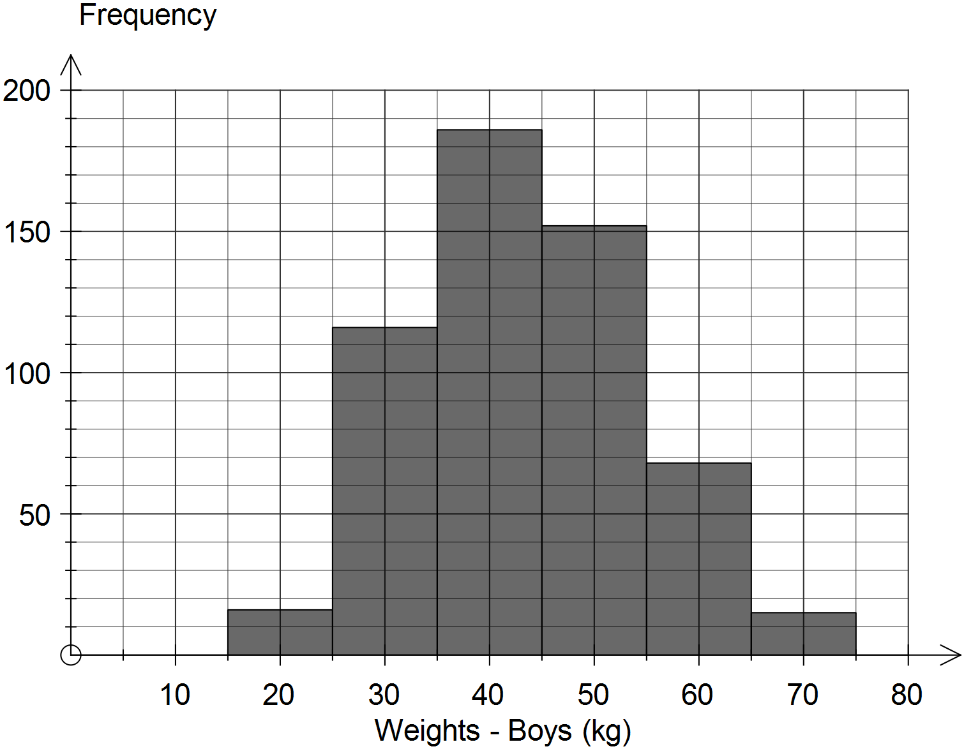

(c) Describe the modality of the distribution of the weights of boys. (1 mark)

(d) Complete the histogram below to show the weight distribution of the girls.

(2 marks)

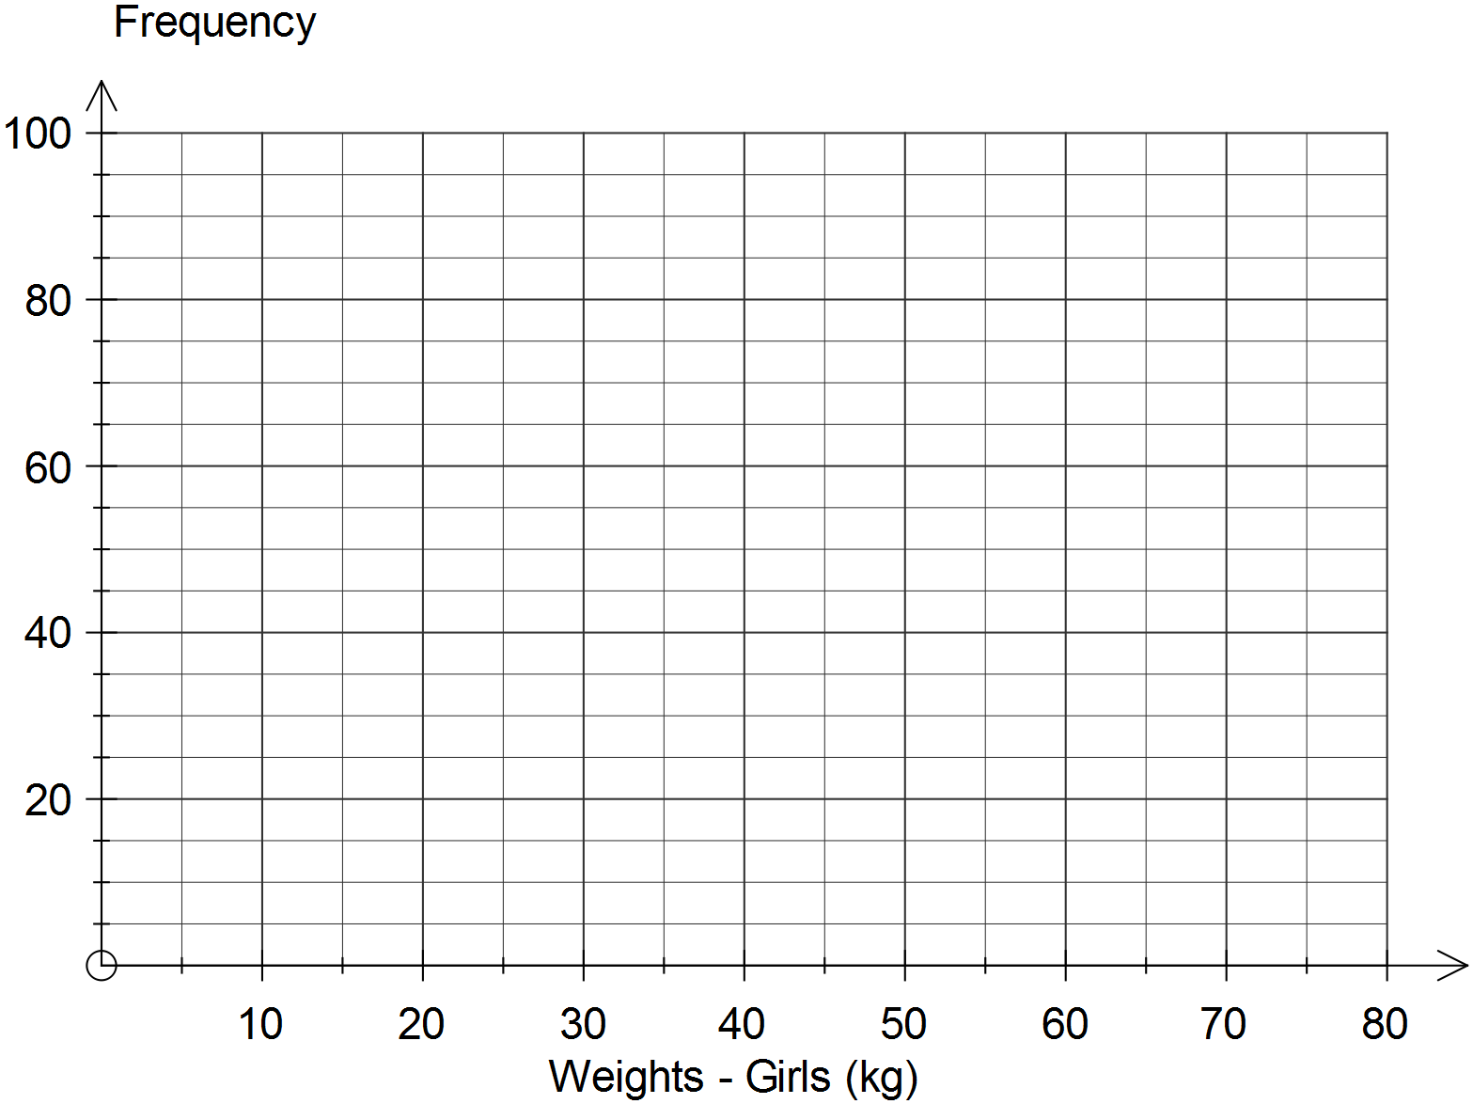

(e) Use the information in this question to comment on any similarities or differences between the weights of boys and girls who take part in the gymnastics program. (3 marks)

Question 16 (10 marks)

(a) A small plane is 22.5 km south and 15.5 km east of an airport. Determine

(i) the distance of the plane from the airport. (2 marks)

(ii) the true bearing of the plane from the airport. (3 marks)

(b) A tree (T) stands on one side of a canal. A lamppost (L) and a flagpole (F) stand on the other bank, 120 m apart, so that $∠FLT=75°$ and $∠TFL=65°$.

(i) Draw a diagram to show this information. (2 marks)

(ii) Use trigonometry to determine the distance, rounded to one decimal place, between the tree and the flagpole. (3 marks)

Question 17 (8 marks)

(a) A student scored a mark of 62% in their English exam and 66% in their History exam. If the marks in both exams were normally distributed with the means and standard deviations shown below, use standard scores to determine the student's best subject.

(3 marks)

|  |  |  |
| --- | --- | --- |
| Subject | Mean | Standard Deviation |
| English | 59 | 14 |
| History | 62 | 16 |

(b) The scaled scores in a national science competition are normally distributed with a mean of 58 and a standard deviation of 11.

(i) Determine the probability that a randomly chosen candidate had a score of less than 65. (1 mark)

(ii) Calculate the probability that a randomly chosen candidate had a score within 15 of the mean. (2 marks)

(iii) 35% of candidates had a score below k. Determine the value of k, rounded to one decimal place. (2 marks)

Question 18 (8 marks)

(a) A house plan is drawn to a scale of 1:200. On the plan, the main bedroom is rectangular and has a length of 26 mm and a width of 19 mm.

(i) Determine the actual dimensions of the bedroom in metres. (2 marks)

(ii) The bedroom is to be carpeted at a cost of $55 per square metre. Calculate the cost of carpeting the bedroom. (2 marks)

(b) A photo and its enlargement have corresponding sides of 15 cm and 24 cm. If the area of the photo is 325 cm2, determine the area of the enlargement. (2 marks)

(c) A spherical balloon, initially filled with 4000 cm3 of air, is deflated until its radius has halved. Calculate how much air remains in the balloon. (2 marks)

Question 19 (8 marks)

(a) A rectangular tile measuring 35 cm by 50 cm has a quarter circle of radius 25 cm cut out to fit around a column, as shown in the diagram below.

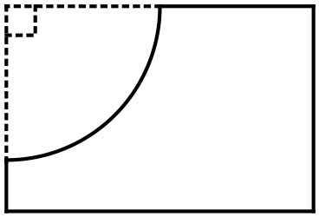

(i) Determine the perimeter of the remaining tile. (2 marks)

(ii) Determine the area of the remaining tile. (2 marks)

(b) A surveyor's sketch of a block is shown. Calculate the area of the block of land.

(4 marks)

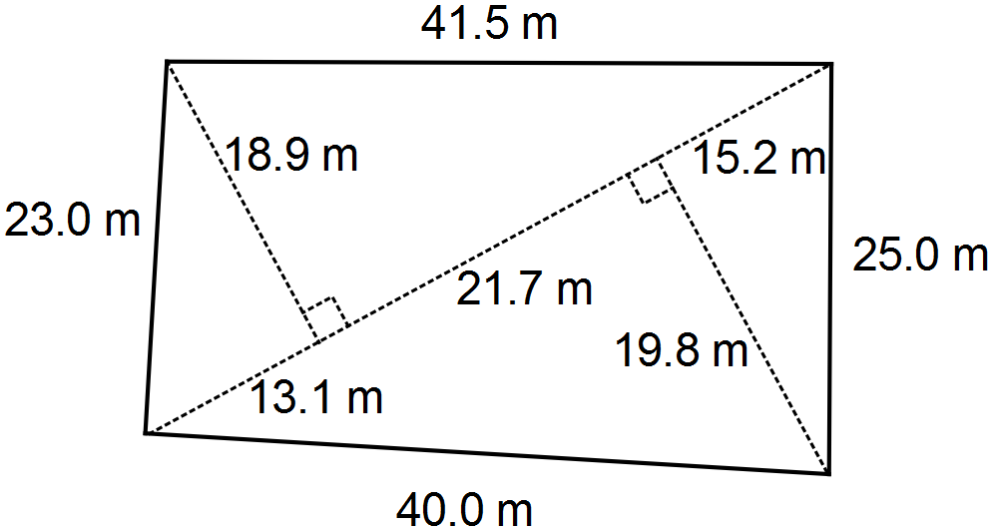

Question 20 (7 marks)

A rectangular swimming pool is 10 m long and has a width of 4.5 m. The depth of water in the pool increases at a constant rate from 1.2 m at the shallow end to 1.8 m at the deep end.

Assume that the pool is full of water to the top of the side walls.

(a) Sketch a diagram to show this information. (2 marks)

(b) Using the formula for the area of a trapezium, or otherwise, show that the area of the sloping side wall of the pool is 15 m2. (2 marks)

(c) Determine how long it would take to empty the pool if it can be drained at a rate of 4 500 litres per hour, and 1 000 litres of water takes up one cubic metre. (3 marks)

Additional working space

Question number: _________

Additional working space

Question number: _________

This examination paper may be freely copied, or communicated on an intranet, for non-commercial purposes within educational institutes that have purchased the paper from WA Examination Papers provided that WA Examination Papers is acknowledged as the copyright owner. Teachers within Leeming Senior High School may change the paper provided that WA Examination Paper's moral rights are not infringed.

Copying or communication for any other purposes can only be done within the terms of the Copyright Act or with prior written permission of WA Examination papers.

*Published by WA Examination Papers*

*PO Box 445 Claremont WA 6910*